Exercise 5 Report | ESP32 sending data using HTTP
  - Nguyen Tieu Phuong 20210692

a) Send the data using HTTP get request, the content-type is url-encoded
Wokwi simulation link: https://wokwi.com/projects/414337719667809281
Screenshot:
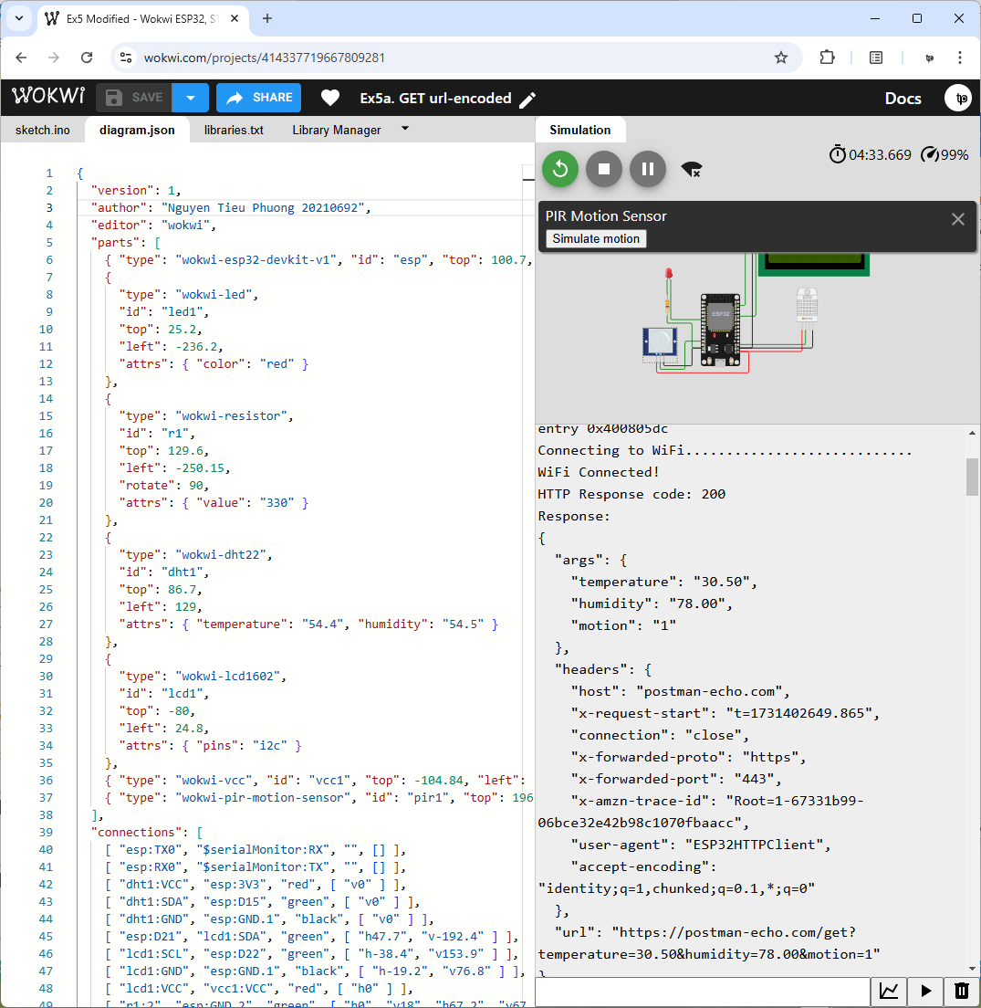
Source code:
#include <WiFi.h>
#include <HTTPClient.h>

const char* ssid = "Wokwi-GUEST";
const char* password = "";

// Server URL
String serverName = "https://postman-echo.com/get";

// Simulated sensor data
float temperature = 30.5;
float humidity = 78.0;
int motion = 1;

void setup() {
Serial.begin(9600);
WiFi.begin(ssid, password);
Serial.print("Connecting to WiFi");
while (WiFi.status() != WL_CONNECTED) {
delay(100);
Serial.print(".");
}
Serial.println("\nWiFi Connected!");
}

void loop() {
if (WiFi.status() == WL_CONNECTED) {
HTTPClient http;

// Build URL with query parameters
String url = serverName + "?temperature=" + String(temperature) +
"&humidity=" + String(humidity) +
"&motion=" + String(motion);
http.begin(url);

int httpResponseCode = http.GET();
if (httpResponseCode > 0) {
Serial.print("HTTP Response code: ");
Serial.println(httpResponseCode);
String payload = http.getString();
Serial.println("Response:");
Serial.println(payload);
} else {
Serial.print("Error code: ");
Serial.println(httpResponseCode);
}
http.end();
} else {
Serial.println("WiFi Disconnected");
}
delay(3000); // Wait before sending the next request
}

b) Send the data using HTTP post request, the content-type is url-encoded
Wokwi simulation link: https://wokwi.com/projects/414338632302853121
Screenshot:
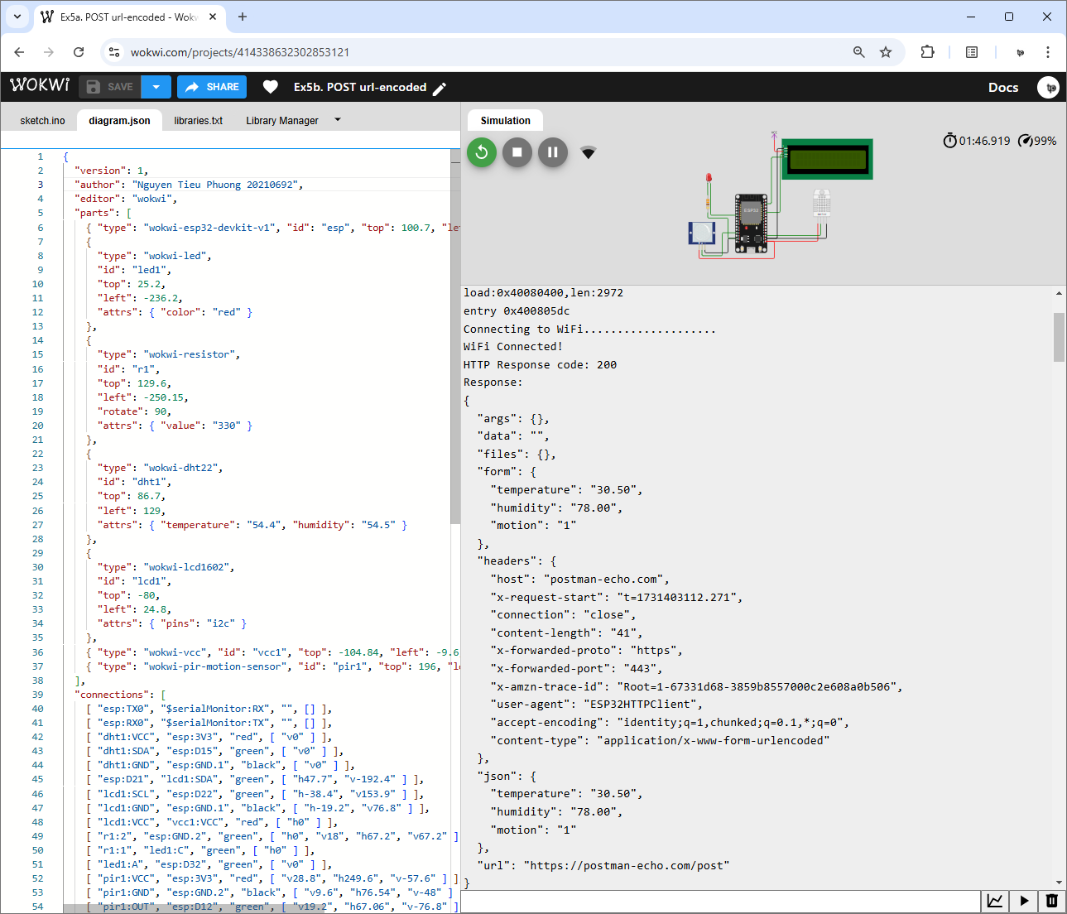
Source code:
#include <WiFi.h>
#include <HTTPClient.h>

const char* ssid = "Wokwi-GUEST";
const char* password = "";

// Server URL
String serverName = "https://postman-echo.com/post";

// Simulated sensor data
float temperature = 30.5;
float humidity = 78.0;
int motion = 1;

void setup() {
Serial.begin(9600);
WiFi.begin(ssid, password);
Serial.print("Connecting to WiFi");
while (WiFi.status() != WL_CONNECTED) {
delay(100);
Serial.print(".");
}
Serial.println("\nWiFi Connected!");
}

void loop() {
if (WiFi.status() == WL_CONNECTED) {
HTTPClient http;

http.begin(serverName);
http.addHeader("Content-Type", "application/x-www-form-urlencoded");

// Create URL-encoded data
String postData = "temperature=" + String(temperature) +
"&humidity=" + String(humidity) +
"&motion=" + String(motion);

int httpResponseCode = http.POST(postData);
if (httpResponseCode > 0) {
Serial.print("HTTP Response code: ");
Serial.println(httpResponseCode);
String payload = http.getString();
Serial.println("Response:");
Serial.println(payload);
} else {
Serial.print("Error code: ");
Serial.println(httpResponseCode);
}
http.end();
} else {
Serial.println("WiFi Disconnected");
}
delay(3000); // Wait before sending the next request
}

c) Send the data using HTTP post request, the content-type is json (in request body)
Wokwi simulation link: https://wokwi.com/projects/414338931386660865
Screenshot:
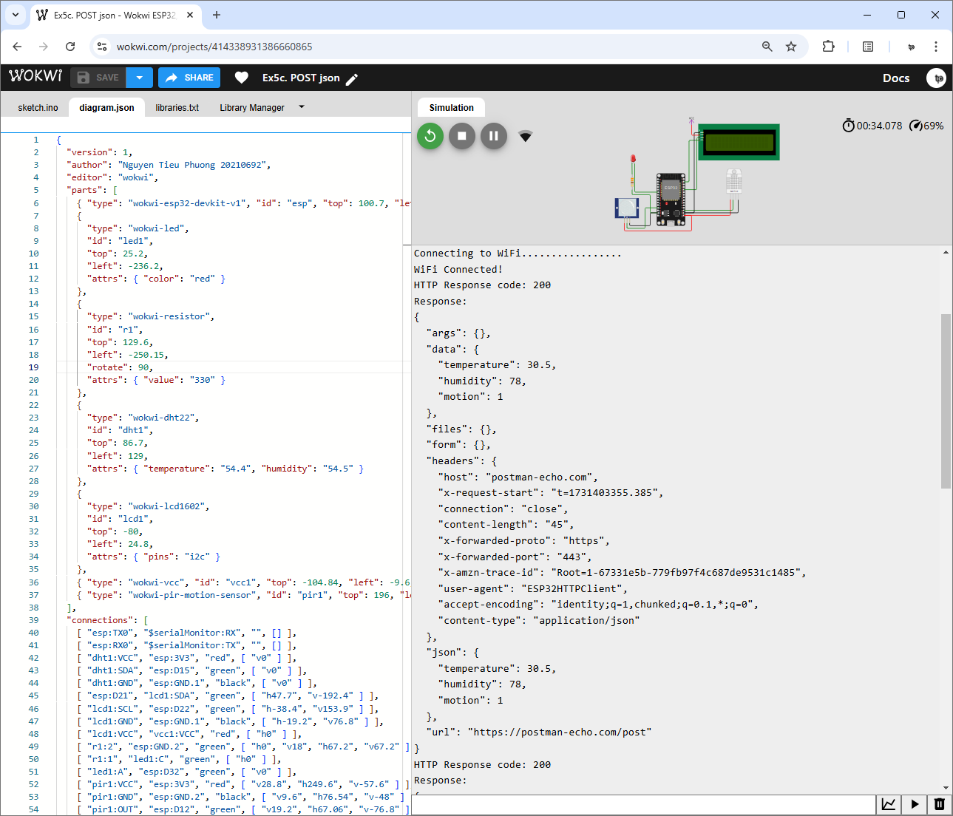
Source code:
#include <WiFi.h>
#include <HTTPClient.h>
#include <ArduinoJson.h>

const char* ssid = "Wokwi-GUEST";
const char* password = "";

// Server URL
String serverName = "https://postman-echo.com/post";

// Simulated sensor data
float temperature = 30.5;
float humidity = 78.0;
int motion = 1;

void setup() {
Serial.begin(9600);
WiFi.begin(ssid, password);
Serial.print("Connecting to WiFi");
while (WiFi.status() != WL_CONNECTED) {
delay(100);
Serial.print(".");
}
Serial.println("\nWiFi Connected!");
}

void loop() {
if (WiFi.status() == WL_CONNECTED) {
HTTPClient http;

http.begin(serverName);
http.addHeader("Content-Type", "application/json");

// Create JSON object
DynamicJsonDocument doc(1024);
String jsonStr;
// Modify directly doc for simplicity since this program uses only single-level JSON structure
doc["temperature"] = temperature;
doc["humidity"] = humidity;
doc["motion"] = motion;
serializeJson(doc, jsonStr);

int httpResponseCode = http.POST(jsonStr);
if (httpResponseCode > 0) {
Serial.print("HTTP Response code: ");
Serial.println(httpResponseCode);
String payload = http.getString();
Serial.println("Response:");
Serial.println(payload);
} else {
Serial.print("Error code: ");
Serial.println(httpResponseCode);
}
http.end();
} else {
Serial.println("WiFi Disconnected");
}
delay(3000); // Wait before sending the next request
}

THE END

